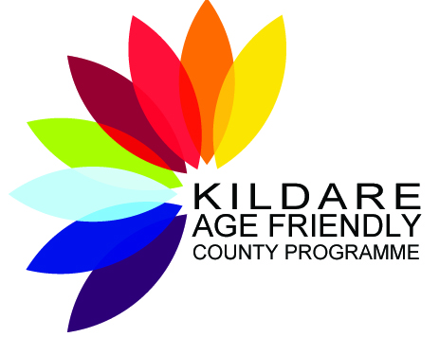

Objectives of Kildare Age Friendly County Strategy
2019 - 2021
Annual progress report
2019

Contents:
Foreword by the Chairperson
Introduction
Kildare Older Persons Council Report
Updates on objectives
- KCC: Roads, Transportation and Public Safety
- KCC: Housing
- KCC: Economic,Community & Cultural Development
- KCC: Estate Management Respect & Social Incusion
- KCC: Social Participation – FAI & Kildare Sports Partnership
- KCC: Library & Arts Services
- KCC: Communication & Information
- KCC: Local Enterprise Office
- KCC: Environmental Services and Water
- An Garda Síochána
- Community Support and Health Services Executive
- KCC: Kildare Age Friendly Programme

Conclusion
Acknowledgements

Foreword from Kildare Age Friendly County Alliance
The Age Friendly Programme recently celebrated it’s 10th Anniversary in Ireland. Kildare has been involved with the programme since it’s inception. This is the first Annual Progress Report in the lifetime of this, our third Kildare Age Friendly Strategy 2019-2021. Our Alliance meets twice yearly in June and December. The members are now very experienced in the delivery of their services and work cohesively together for the benefit of older people in Kildare whether as a unit or in sub-groups. The Age Friendly Programme itself is now embedded in Local Government with the National Age Friendly Office now located within Meath County Council. The Kildare Age Friendly Programme has made huge strides in the past year and has branched out into areas such as creating Age Friendly Towns, writing guidelines for Age Friendly Primary Care Centres and every Department within Kildare Local Authority are now comfortable and knowledgeable in their decision making process of making their services age friendly. The demand for age friendly services continues to grow as the number of older people increases in Ireland. 2019 also saw a new Kildare Older Persons Council Executive formed who are excellent at representing the voice of the older person from all corners of Kildare. The programme has had a very successful and expansive year in 2019 and the new Strategy 2019-2022 is another opportunity to focus on the evolving requirements of the ageing population and making real changes possible for the older people of Kildare. One of our greatest achievements in the past year is that our programme manager now divides her time between her county role and as South East Regional Programme Manager servicing six counties in the region.
--------------------------------------------------------
John Malone
Chairperson
Kildare Age Friendly Programme
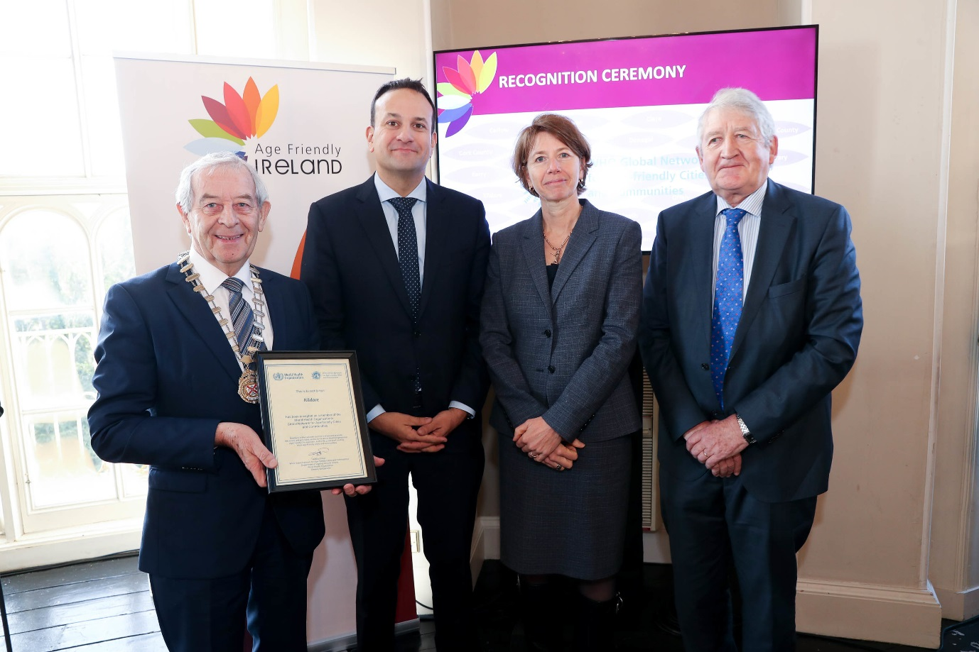
Recognition Cremony of 10 years of the Age Friendly Programme

INTRODUCTION
This is the End of Year Report for 2019. The 2019-2021 Kildare Age Friendly Strategy commits to the next level of service commitments by the Service providers and Kildare Older Persons Council Executive for the overall and specific wellbeing of older people in Kildare until 2022. The task is not just to improve delivery of services in Kildare but to future proof for the population who will inevitably reach older age in the future. The strategy has been developed by the Kildare Age Friendly Alliance in consultation and co-operation with over 800 older people in Kildare. The work completed by both the Alliance and Executive in 2019 is testament to the groundwork over the past number of years making real and definitive change possible. The following reports by the Service Providers are both eclectic and strong and clearly show their continued commitment to the programme. The feeling all round is one of being a participant in an enormous worldwide structure led by the World Health Organisation in implementing their identified 8 themes. The best news of 2019 is that Ireland has been appointed as the first age friendly country in the world, proof positive of the commitment of all 31 Local Authorities and other agencies.
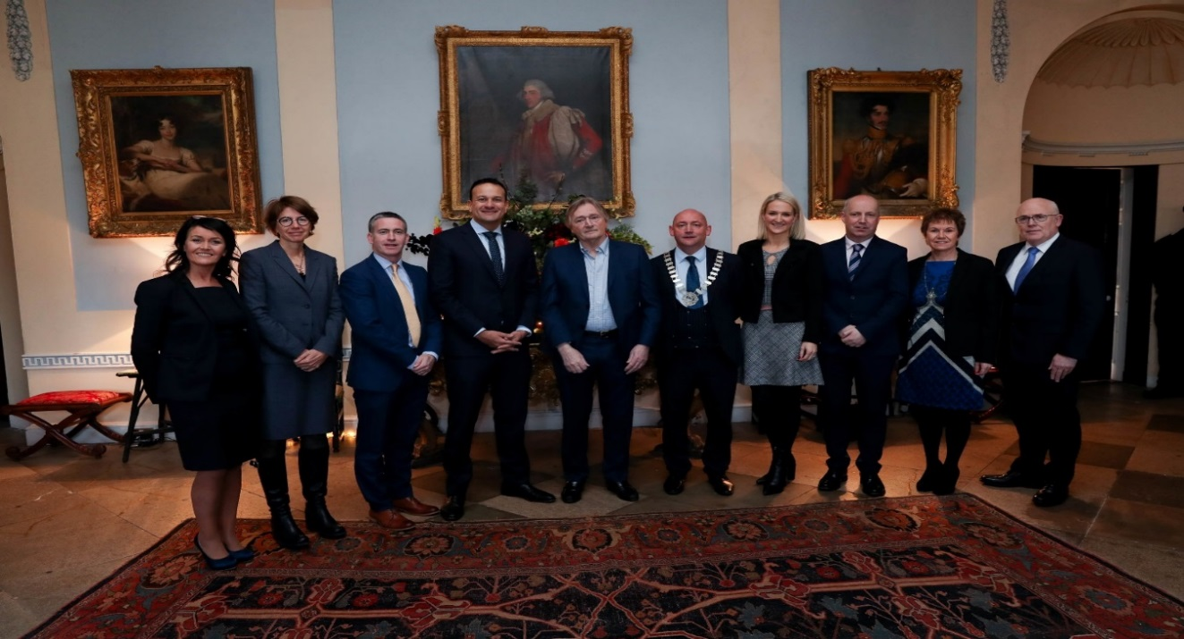
Slane Castle Age Friendly Ireland Recognition Ceremony 10 years of Age Friendly Programme in ireland
Introduction from Monica Cox & Kildare Older Persons Council
The Kildare Older Person’s Council (OPC) Executive constituted in early 2017 came to the end of its two-year tenure at an Annual General Meeting held in April 2019. At that AGM, Expressions of Interest Forms were received from people who wanted to become part of a new Kildare OPC Executive, and following a period of training and induction, they joined with experienced members from the previous one, to form the new 2019-2021 Executive. Locally in 2019, members of our OPC had ongoing contact and interactions with older people in the Municipal Districts through age-friendly events and their connections with, and membership of, Active Retirement Groups, Men’s Sheds, Kildare Public Participation Network and other Social & Recreational organisations for older people. The Chairperson of Kildare OPC represented the voice and views of older people at all 2019 meetings of Kildare Age Friendly Alliance and Kildare Joint Policing Committee.
At Regional level in 2019, we teamed up with our County Wicklow OPC counterparts and participated in two detailed consultation workshops about the design, function and layout of Primary Care Centres, alongside both counties' Age Friendly Programme Managers and representatives from the HSE.
Nationally in 2019, The Chairperson interacted with Age Friendly Ireland, engaged with the National Network of OPC Chairs, and contributed to its National OPC Guidelines Subgroup who are currently refreshing guidelines for the composition and functioning of OPCs countrywide. There is an impressive amount of work going on at National Level, including the setting up of Age Friendly Libraries, Hospitals and Airports. These exciting developments will filter through to involve the OPCs in all participating counties and local authority areas so we anticipate busy times ahead.
Kildare OPC Executive were also delighted to participate in the launch of the Kildare Age Friendly Strategy 2019–2021 and look forward to working in a spirit of partnership with service providers who are part of the Alliance over the next two years.
Roads, Transport and Public Safety

Aim:
To take an Age Friendly approach when improving the public realm as part of roads improvement projects.

Objectives:
To evaluate existing projects in order to prioritise future work. Expand and develop successful initiatives where appropriate, in order to improve access and ease of use.

Progress: Ongoing

Aim:
To develop awareness among older people of the existing public transport services available to users within the county.

Objectives:
- To Identify optimum locations in towns for display of transport timetables.
- Create and publicise a link to relevant websites to ensure that information is readily available regarding transport services, routes and fees.

Progress: Ongoing

Aim:
Link with the relevant transport companies in order to improve access for our older population to hospitals and clinics.

Objectives:
Ongoing consultation with Age Friendly Alliance Focus Group.

Progress: One of the transport companies has met with the HSE to map out the current systems and to identify possible improvements for the older persons access to Hospitals. HSE Older Persons & Health and Well Being will continue to work with Kildare Soputh Dublin Local Link ltd., to identify supports required within the community to transport the older population for clinical reviews and social networking.

Housing

Aim: To plan and assess future housing needs of older people in County Kildare through housing needs assessments.

Objectives: To continue to consult housing needs assessment in the context of future delivery of social housing units.

Progress: Under Rebuilding Ireland Action Plan for Housing and Homelessness, annual housing needs assessments [HNA] are carried out. A HNA was completed in 2019.

The statistical information provided following the analysis of the annual housing needs assessments will assist the housing department to plan and design housing schemes for future needs of older people in our county.

KCC Allocations Team and Internal Case Conferences have commenced.

Ongoing monitoring of housing needs and assessment of suitability of available properties for persons 65 years of age or over with particular attention to the allocation of ground floor accommodation when available and appropriate.
Internal case conferences ongoing.

Under Rebuilding Ireland Action Plan for Housing and Homelessness, annual housing needs assessments [HNA] are carried out. A HNA was completed in 2019.

KCC Traveller Accommodation Plan 2018-2020 - Quarterly meetings of Local Traveller Accommodation Consultative Committee (LTACC
Progress: 4 LTACC meetings held with ongoing monitoring of accommodation needs for person 65 years of age or over. The Traveller Accommodation Unit4 LTACC meetings held with ongoing monitoring of accommodation needs for person 65 years of age or over. The Traveller Accommodation Unit provided specific additional supports to older persons on sites in 2019 including refurbishment of a day house and provision of a mobile home.

Mid East Region Homeless Action Plan 2018-2020
Quarterly meetings of the Mid East Region Local Authorities: Kildare, Meath, Wicklow ongoing
4 meetings of Mid East Region Senior Management Group and Forum held.

Aim: To support the provision of older person housing through approved housing bodies.

Objectives: Continuing support for older persons housing through approved housing bodies, particularly in the context of Capital Assistance Scheme [CAS] funding.
Lead partner: Kildare County Council, Housing

Progress: Engagement has commenced with approved Housing Bodies (AHB’s to progress the provision of social housing.)

Kildare County Council’s housing department is actively working with Approved Housing Bodies [AHBs] to progress the provision of social housing units across the county, through acquisition and leasing, which will support the provision of housing for older people in the county

In order to take account of the additional needs older tenants may have in accessing the tenant liaison service and provide an outreach service when necessary Kildare County Council’s Housing Department works in close collaboration with older tenants across the County through the Tenant Liaison Officers who in turn link in with the various services to provide an outreach service as necessary.

Aim: To meet the requirement of lifetime adaptability in housing needs.

Objectives: To provide a percentage of housing in new social housing developments constructed with lifetime adaptability in mind. In some instances end user specific housing is constructed where a tenant with a specific need is identified at the design stage need.

Progress: Kildare County Council‘s Housing and Disability Steering Group has agreed a Strategic Plan for Housing Persons with a Disability. The Strategy takes into consideration that the requirements of people with a disability will need to be factored into emerging housing projects from the outset. Targets and objectives have been set for delivery of units for people with disabilities.
In accordance with Part M of the Building Regulations, the Design and Construction of new houses, there is a requirement that new dwellings ‘are visitable’ with the intention of ensuring that all new builds meet access requirements as set out in the Regulations

All new housing designed or constructed by Kildare County Council in 2019 was designed or constructed in compliance with Part M of the Building Regulations and are visitable.

Aim: To support householders to remain in their homes and sustain independent living as they get older, through the provision of the Housing Aid for Older People Grant scheme, the Housing Adaptation for Persons with a disability scheme and the mobility aids housing grant scheme (subject to eligibility criteria).

Objectives: Schemes will continue subject to availability of funding from Department of Housing, Planning and Local Government.

Progress: Kildare County Council’s housing department is committed to facilitating access to eligible applicants for Housing Aid for Older People Grant, Housing Adaptation for Persons with a Disability Scheme and Mobility Aids Scheme, subject to continuation of funding provision by the Department of Housing, Planning, Community and Local Government. The members of Kildare County Council continue to make provision for the local authority’s contribution to these grants schemes in their annual budget.
The following grant allocation were made in 2019 (as of November 31st2019)

Housing Aid for the Elderly: 222

Housing Adaptation for Persons with a Disability: 301

A budget of €3.1 million is available for the provision of grants for private home owners (including housing aid for older persons). This budget has been fully expended for 2019.

Economic, Community & Cultural Development Section

Aim: Ensure the needs of older people are identified when carrying out the health checks under the Town and Village Rejuvenation Scheme.

Objectives: Carry out Walkability Audits in towns when identified and involve Kildare Older Persons Council in the process.

Lead partner: Kildare County Council

Progress:Celbridge, Athy and Castlefen Sallins completed

Respect & Social Inclusion

Aim: Community Workers to promote Age Friendly Programme in Local Authority Estates.

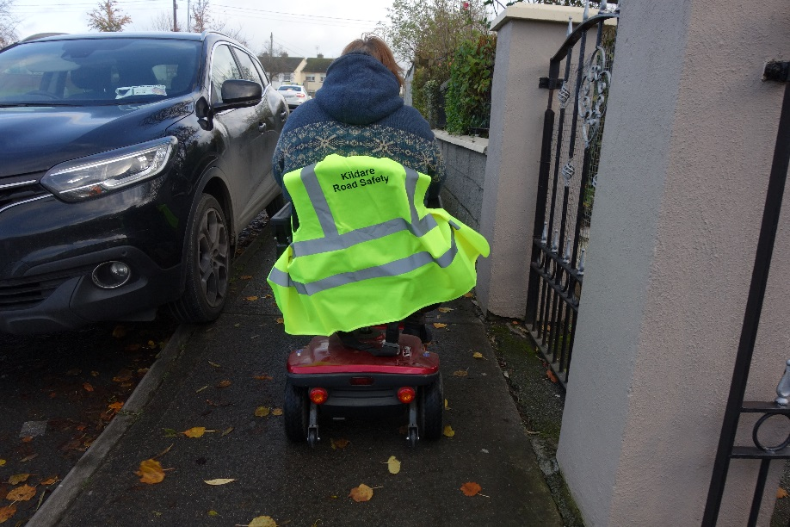

Objectives: Support and facilitate the establishment of Age Friendly Estates.

Progress: Castlefen Sallins completed, other estates initiated

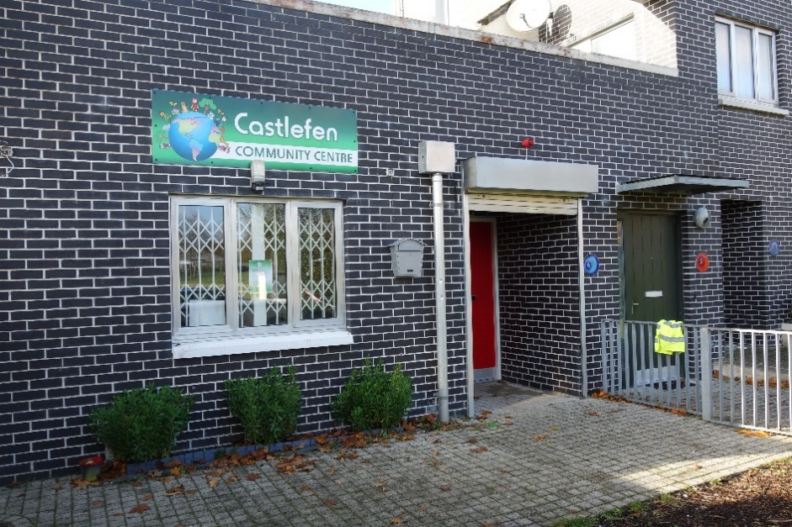

Social Participation - Sports

Aim: A aim of Kildare Sports Partnership is to engage as many older people as possible in physical activity in the wider community

Objectives:

- Establish and deliver - Operation Transformation Programme
- ACTIVATOR Walking Programme
- Seated Exercise Programme
- Aqua- aerobics Programme
- Activity Fest
- Scooch Blitz for Mens Sheds
- ACTIVATOR Training Workshop
- FitSTICKS Training Workshop.
- Organise and deliver 2 Health, wellbeing Sports Festivals north & south of the county.

Progress: All completed for 2019 and ongoing 2020

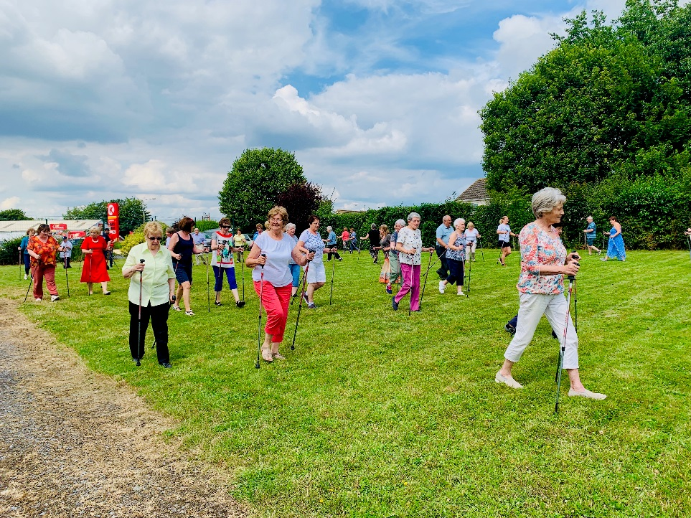

Aim: FAI to support activities for the older person.

Objectives: Establish Walking Football teams countywide.
Lead partner: Kildare County Council, Economic, Community & Cultural
Development

Progress: Ongoing, assisted by Gardai Kildare Division

Library Service

Aim: Libraries will offer cultural services, collections and activities for older people.

Objectives: Kildare Library Service continued to target older people in Co. Kildare with varied collections, cultural and recreational programmes of events, workshops and technologies.
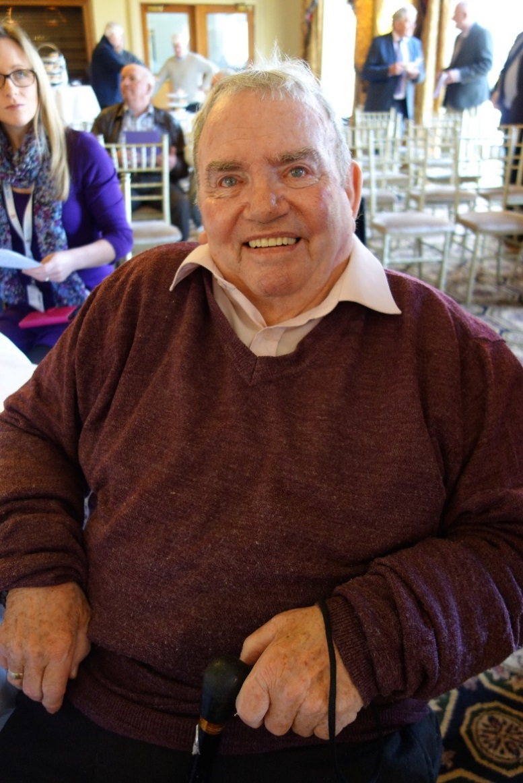
Progress: In 2019 the Age Friendly Older Wiser Laughter (OWL) Programme delivered over 64 workshops and talks in the main library branches and these specifically targeted at older people throughout Co. Kildare. Content included wood carving, wild food foraging, genealogy, painting, drumming, chair yoga, e-services and weaving. The Gardaí and the Library service worked together to organise a new series of information talks which provided advice and tips on improving personal safety and security. As part of its residency in the Riverbank Arts Centre and with Kildare County Council Library and Arts Service, Collapsing Horse Theatre carried out closed workshops with the University of the Third Age in Maynooth and the Naas Day Care Centre. Age Friendly Library Day took place on Friday, 10th May and it was an opportunity for libraries to get to know their older users over some refreshments. It was also a chance to find out first-hand what services and resources the library has to offer. Kildare Library Services Age Friendly Co-ordinator attended Kildare Sports Partnership’s Older Adult Wellness Event in the Curragh Racecourse on 12th June and the Active Retirement Ireland Trade & Tourism Show in Punchestown Event Centre on 5th June. This was a great opportunity to promote libraries to the older audience and demonstrate our e-Services

Aim: Library facilities in Kildare will be upgraded with the accessibility requirements of older people in mind.

Objectives: Kildare Library Service will continue to develop library spaces for people at all stages of life.

Progress: Having achieved a model of accessibility in the Athy Library project, Kildare Library & Arts service will continue this work to achieve the same outcomes with the requirements of older people in mind. The two new capital building projects Naas Library & Clane Library will be finished as spaces for all stages of life.

Aim: The Age Friendly library was created by consulting with the local community to design and implement a strategic plan to achieve age friendly library goals.

Objectives: Age Friendly Libraries status for libraries throughout the country is being progressed in partnership with the Libraries Development Unit of the Local Government Management Agency (LGMA) and Age Friendly Ireland.
The first Age Friendly Library delivered in Athy. The Age Friendly Library Recognition Programme is an initiative of Age Friendly Ireland in conjunction with the Libraries Development Committee and CCMA to encourage libraries to develop in a more age friendly way. Athy Library was nominated as the Age Friendly Library for Kildare Local Authority and it received its Age Friendly Charter from Minister Michael Ring on 1st October in Kevin St Library where the National Age Friendly Libraries Recognition Programme was launched. As part of the programme, Kildare Library Services conducted an Age Friendly Survey to find out how ‘Age Friendly’ Kildare Library Service is and how it can be improved and what actions need to be put in place to get recognised as an Age Friendly Library Service. The Survey also extended to the OWL Age Friendly Programme of events/talks/workshops.

Whilst 99% of those surveyed felt their library was ‘Age Friendly’ with very helpful staff, there was a big demand for increased opening hours and more advertising of events taking place in the library.

Following on from this feedback, Kildare Library Services came up with three commitments for our Age Friendly Charter:
1. Continue the work start in Athy Library to achieve a model of accessibility and inclusion with the requirements of older people in mind
2. Increase opening hours in the main Kildare branches
3. Review of our marketing literature for the Libraries Age Friendly (OWL) Programme to target a wider, bigger audience.

In the second half of 2019 all seven main branch libraries and four part-time branches increased their opening hours allowing for greater accessibility and improved Library service delivery throughout the county.

Arts Service

Aim: The Arts Service aims to deliver programmes suitable for service users and carers, especially in the area of mental health and wellbeing.

Objectives: The Arts Service will continue to develop programmes that support older people, service users and carers, particularly in wellbeing, mental health and dementia.

Progress: Ongoing

Communication and Information

Aim: Create a collaborative and coherent communications structure for Alliance partners, ensuring they work cohesively towards achieving the objectives of the overall strategy.

Objectives:

- To organise and host Alliance meetings.
- Establish working groups to work on key projects and programmes as required.
- Provide training, capacity building and support for the Kildare Older Persons Council to enable them to reach their goals as set out in their annual work programme.

Progress: Strategy completed and launched. All other objectives completed.

Launch of the Kildare Age Friendly Strategy 2019-2021
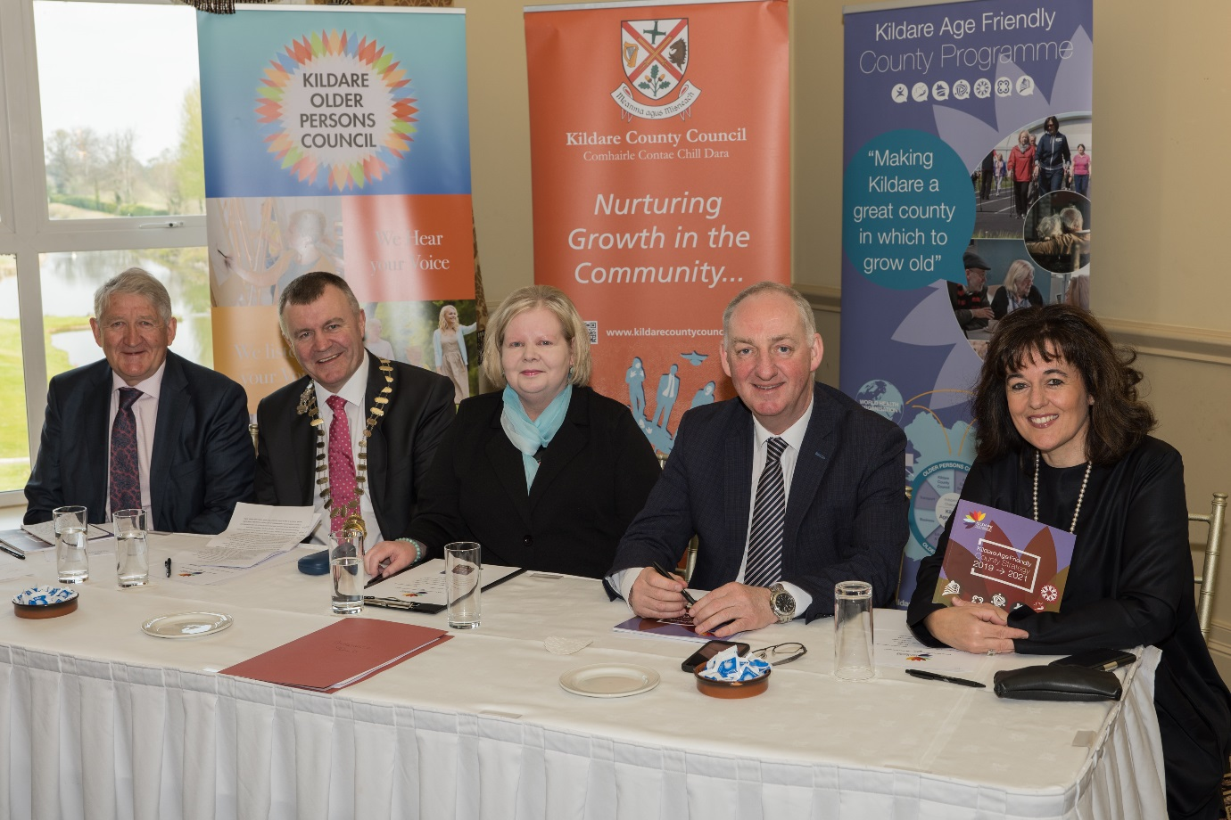

Aim: Promote the programme and its’ objectives, ensuring that the activities of the Alliance are communicated to all stakeholders, to older people and the public at large.

Objectives:
- Produce and disseminate Age Friendly Newsletters across county Kildare.
- Develop the Kildare website in partnership with Age friendly Ireland.
- Host focus groups/workshops when required to hear the voice of older people.
- Work with the National Office to Investigate the use of platforms such as Twitter etc and implement when required in order to communicate with older people about projects and programmes of interest to them.
- Use communication tools and activities as identified in the Communication and information plan.
- Produce and circulate an Annual Report.

Progress: All completed except website, awaiting direction from Age Friendly Ireland.

Aim: Identify lead partner to update the communication and Information booklet.
Objectives: Produce copies of Information Booklet and circulate them.

Progress: In progress

Local Enterprise Office

Aim: Liaise with Age Friendly Ireland to deliver a business recognition scheme in Kildare.

Objectives: Facilitate the identification of a lead partner and support the implementation of the business recognition scheme.

Progress: LEO Office rolling out scheme

Environmental Services & Water

Aim: Develop awareness among older people in county Kildare of the services, issues and opportunities pertaining to environmental management.

Objectives: To provide Information regarding rollout of National smoky coal ban, pending – confirmation of details nationally.

Progress: Completed and ongoing

Aim: Strengthen the relationship between the older people of Kildare and the various environmental groups around the county in order to develop better environmental practice.

Objectives: Provide more talks / workshops / information sessions in order to educate, inform, and encourage older people on various environmental issues and how to gain maximum marks in the Tidy Towns competition.

Progress: Waste water talks for active retirement groups ongoing, Network meetings with Tidy town’s groups ongoing. Mens’ Sheds groups manufacturing wooden composter units for green waste in housing estates as required. Regional Tidy Towns events and climate action workshops ongoing.
Gardaí

Aim: To help older persons in Kildare protect themselves from crime by increasing engagement with the Crime Prevention Unit.

Objectives: Crime Prevention Officer and Kildare Community Policing to provide personal, home, farming and financial security advice presentations at Older Persons Road Shows, Active Retirement groups on a county wide basis.

Progress: Presentations to ICA groups, Text Alert groups, Active Retirement Groups and IFA fraternity – ongoing.
Community Gardai, CPO and ‘Know your patch’ liaison Gardai engaged with and presented to community groups on issues surrounding crime prevention. “Text Alerts” continue to issue to community groups. Linkages with Library Services re; OWL programme.

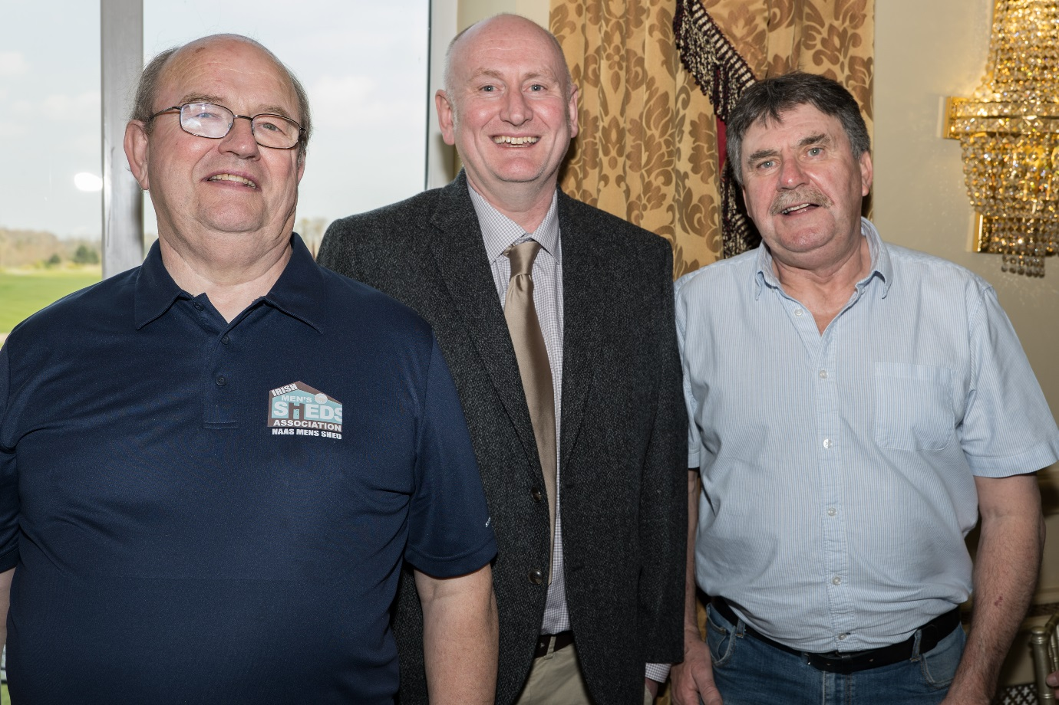

Crime Prevention Officer with members of Naas Mens Shed

Community Support & Health Services

Aim: HSE to consult with Kildare Older Persons Council in relation to healthcare for the older person.

Objectives: HSE representatives on the Age Friendly County Alliance in Kildare to work closely with members of the Kildare Older Persons Council to listen to the issues in relation to healthcare provision for older people and to address these issues.

Progress: The HSE remains open to discussing any issues or suggestions from the Kildare Older Persons Council. The HSE and representatives from the Older Persons Council have collaborated regarding voluntary agencies in the Kildare area in order to share information regarding older persons services

Aim: Link with Kildare Sports Partnership to develop an exercise and physical activity programs for older people to help ensure their continued mobility.

Objectives: Supporting all other Healthy Ireland Activities through Healthy Ireland Implementation plan 2018-2022.

Progress: The HSE, Health and Wellbeing division and Older persons services are exploring the development of links with Kildare sports Partnership to enhance the mobility of the Older Person in County Kildare. Initiative identified will be developed to support continued mobility for older people where appropriate.
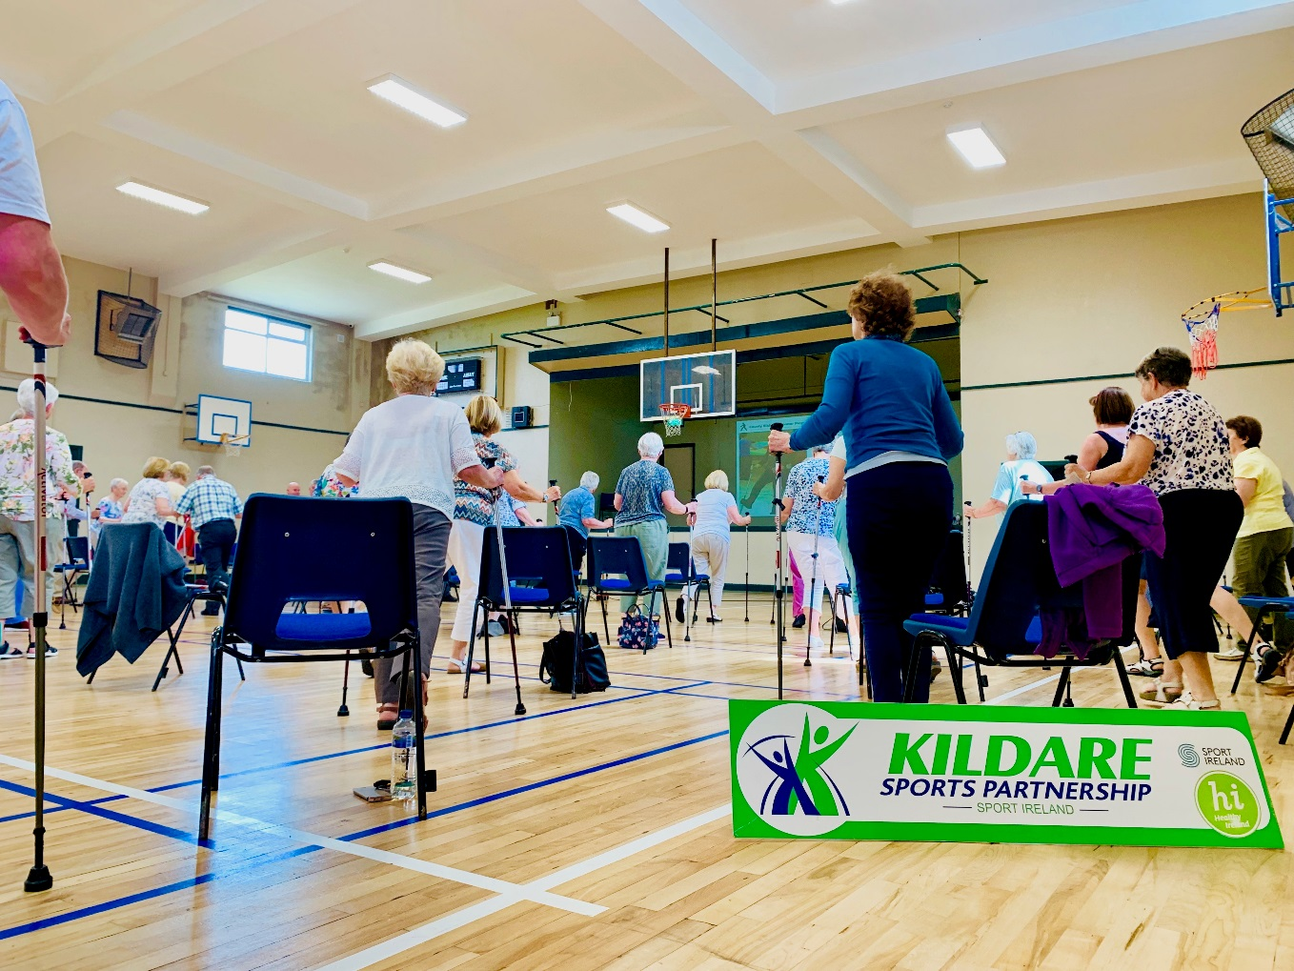

Aim: Representatives, in collaboration with the Alliance and voluntary agencies, will strive to create awareness of dementia, by establishing a steering group to facilitate a workshop for carers.

Objectives: Establish Steering Group.

Progress: The HSE continues to progress the National Dementia Strategy in County Kildare. In addition to the Dementia Awareness day which incorporated speakers from three universities, HSE representatives liaised with Kildare County Council to identify speakers for the Kildare Age Friendly Dementia Road shows. HSE personnel also attended the road show and will continue to work in partnership with Kildare County Council in improving Dementia Awareness in Kildare. It is envisaged that the HSE carers will be trained specifically in the area of Dementia care. This is an ongoing project and will enhance the quality of care delivered to the older person in their own homes in Kildare.

Aim: Link with local Gardai to create a register of vulnerable adults.

Objectives: Continue to update register.

Lead partner: Health Service Executive

Progress: The setting up of this register is currently in progress. GDPR needs to be adhered and this has added to complexities to this task.

Kildare Age Friendly Programme

Aim: Co-ordinate and deliver the Age Friendly programme for County Kildare in partnership with all relevant agencies and Age Friendly Ireland.

Objectives:
- Instigate and support the two Health & Wellbeing festivals to be held in North & South Kildare.
- Provide and facilitate Walkability Audits as requested county wide.
- Provide facilitation and support for the establishment of Age Friendly Towns.

Lead partner: Kildare County Council, Economic, Community & Cultural Development

Progress: One large Festival encompassing North and South Kildare held, walkability audits completed in Clane, Athy and Castlefen Local Authority project estate. Celbridge now Age Friendly Town and Athy in progress

Aim: To work closely with the Local Community Development Committee to achieve objective 1.3 under Goal 1 of the “Kildare Local Economic and Community plan 2016-2021”

Objectives:
- 1.3.1 To give ongoing support to the Kildare Age Friendly Alliance in implementing their strategy when completed.
- Link with the Local Community Development Committee, INTREO & County Kildare Leader Partnership when required to promote employment supports and opportunities for older people.

Lead partner: Kildare County Council, Economic, Community & Cultural Development

Progress: Alliance 2019-2021Strategy completed and being rolled out. Work with LCDC, INTREO and Leader Partnership ongoing,

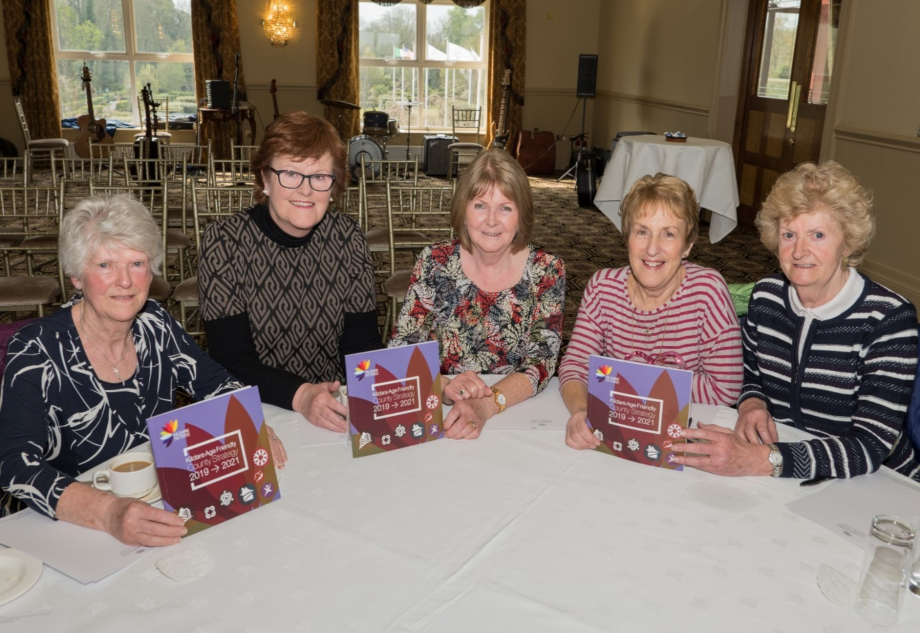
Conclusion:
2019 has been a year of endings and beginnings for both the Kildare Age Friendly Alliance and the Kildare Older Persons Council. We came to the end of the 2016-2018 Strategy and launched the 2019-2021 Strategy. It was also time for a new Older Persons Council as most members had been in service for two terms. We are very pleased that a new Kildare Older Persons Council is now in place for the next two-year term.
On reviewing the Alliance 2016-2018 Strategy and the completed workplan for the Older Persons Council it became very obvious that great strides had been made by both the Alliance and the OPC and all the aims and objectives had been more than adequately met.
The Kildare Age Friendly Programme has transitioned very well and with the wisdom of the more established members and new members coming on board, the programme is in a very healthy state going into the next decade.

Acknowledgements:
We would like to acknowledge the support of Age Friendly Ireland and our newly appointed Regional Co-ordinator for their advice and direction over the past year.
We especially want to thank the older people of Kildare who always come out in their numbers and participate in whatever events are taking place relating to them.
We anticipate great expansion of the programme in the coming year and feel that both the Alliance and Older Persons Council are well equipped to take the programme to greater heights for the benefit of all.

